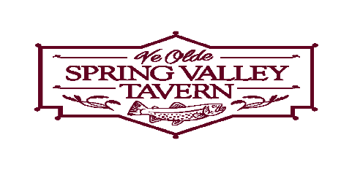
Restaurant Week Menu

Lunch $15.00

Choice of Soup or Small Salad

Sandwiches (All served with Hand Cut French Fries except the Salad)
Crabcake Sandwich
Spring Valley Steak Sandwich
Pot Roast Sandwich
Spring Valley Steak Salad
*Substitute Sweet Potato Fries, Onion Rings or Pierogies for $2.00 more*
*1 Soda, Lemonade or Ice Tea included*
Dessert
Coconut Cake / Tiramisu Cake / Chocolate Mousse

Dinner $26.00

Choice of Soup or Small Salad

Appetizer
Chilled Smoked Trout
Chicken Kickers
Trout Dip

Entrée
(includes vegetable & starch)
Chicken Marsala
Cajun Trout
6 oz. Filet
Scallop, Shrimp & Crab Scampi over Linguine w/Garlic Bread
Dessert
Coconut Cake / Tiramisu Cake/ Chocolate Mousse

*NO COUPONS ACCEPTED*

