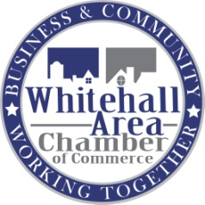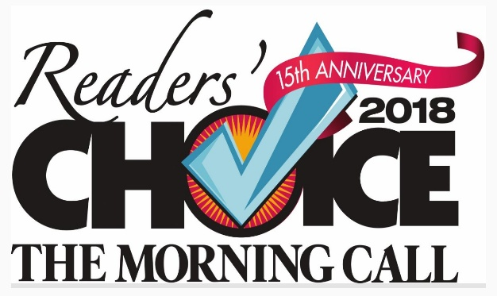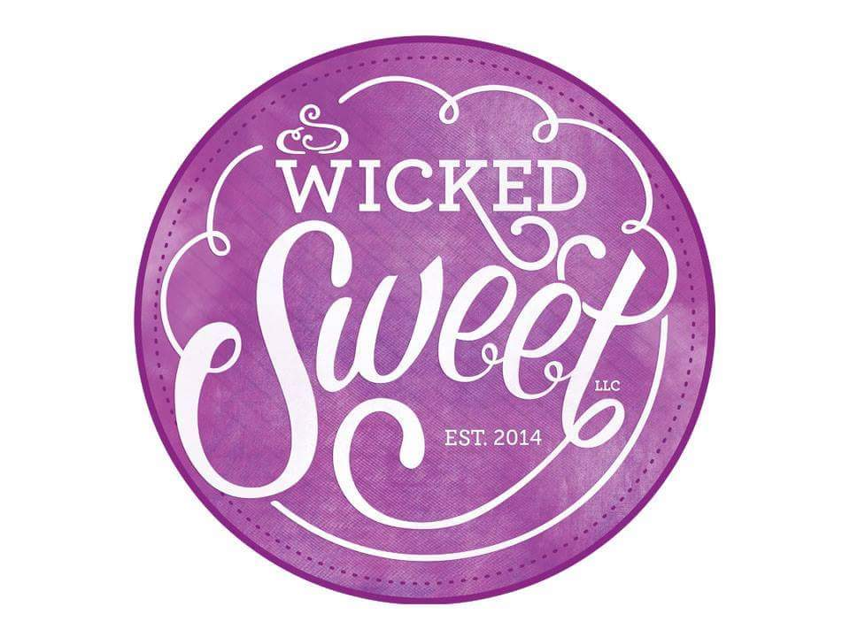

**2018 Morning Call Readers’ Choice for**

**BEST BAKERY in the Lehigh Valley!**

We are a small grab and go bakeshop that specializes in baked goods & custom cakes.

We take pride in making cakes for all events- large and small. That not only taste great, but make awesome centerpieces on the dessert table!

In our cases you'll find 6-9 flavors of cupcakes, donuts, pastries, brownies, muffins and other sweet treats.

For the holidays we offer assorted trays, creampuffs, cannoli, cookies, pumpkin roll, pies and dessert style cakes to supplement the sweets you make at home with your family.

**Whitehall's Restaurant week specials:**

**\* save $2.00 on a 6pack of cupcakes**

**\* BOGO cookie special**

**\* 2 turnovers $5.00**

**WiCKED SWEET BAKESHOP**

**3010 s. 2nd street Whitehall**

**610 841 0899**

**Wednesday-Friday 11am-6pm**

**Saturdays 10am-2pm**