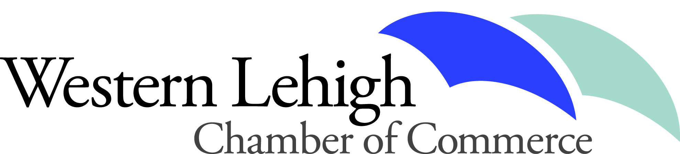
c/o Ashley Lorah
(p) 610-739-1273
AshleyL@lehighvalleychamber.org
Western Lehigh Chamber of Commerce
191 Main Street Suite 205, Emmaus, PA 18049

Western Lehigh Area Restaurant Week June 9th – 15th 2019.
Presented by

Dear Restaurant Owner,
The Western Lehigh Chamber of Commerce would like to cordially invite you to participate in our Western Lehigh Area Restaurant Week, taking place from June 9th – 15th, 2019.
- The intention remains twofold: 1. For restaurants, it is a week during a relatively slow time of year to boost their sales by both encouraging new customers to experience their food and persuade returning customers to bring their friends/family - by offering fixed menus with special prices. 2. For the Western Lehigh business community, it is a chance for visitors to be exposed to the area and surrounding shopping district – an opportunity for visitors to experience the Western Lehigh Area and its downtowns!
- Participating Restaurant Week locations create “set-price” or “prix fixe” menus, offering a choice of appetizers, entrees, and desserts at promotional prices. Restaurants can participate by providing offerings for lunch and/or dinner.
- Each location will also contribute 2 gift certificates toward the Western Lehigh Area Restaurant Week campaign for promotional giveaways. The event will be promoted through a variety of avenues (listed below). Chamber Members are invited to participate for just $60! (Future Chamber members may participate for $120)
- Restaurant Weeks in neighboring regions have been recorded to bring in more than 10,000 people to participating restaurants combined! Some restaurant owners shared that they had seen a 30%-40% increase in sales, and 70%-90% of customers were ordering off of Restaurant Week menus! Our goal is to have 10 locations participate and benefit.

- Recently the East Penn Chamber held a very successful Restaurant week. Carl Billera, Owner of House and Barn, shared this note: ‘We were very pleased with the results and the new patronage it created for our very young restaurant. Our exposure immediately increased and we look forward to many more years of involvement'.

We are proud of the diverse dining options that make Western Lehigh a unique region for people of the Lehigh Valley to explore new cuisine in a variety of atmospheres. We hope that you will consider joining us as we encourage diners to “Dine Out IN Western Lehigh”!
Be a part of this year’s success with this opportunity to put your name in front of thousands of people!
Advertising and Promotional Avenues for the event have included / may include the following:
- Print Advertising – The Morning Call and Lehigh Valley Press.
- Radio Advertising – B-104/ WAEB/WZZO (iHeart Radio)
- Western Lehigh Area Restaurant Week Webpage – which will include the menus for viewing and sponsor recognition
- Facebook – Individual event page and posts on WLCC and GLVCC pages
- Greater Lehigh Valley Chamber’s Connections Magazine (mailed to over 5,000 members) – Event listed in calendar, event ad, and mention in monthly article written by the Western Lehigh Chamber of Commerce Chair.
- Geographic Chamber e-blast to Hellertown/Lower Saucon, Southern Lehigh, Nazareth, Bath, Greater Northern, Whitehall, Northampton, East Penn, and Western Lehigh communities, scheduled for 6/5/19. Event Poster distributed to participating restaurants and event sponsors.

We understand that June will be here before we know it! THE DEADLINE TO BE INCLUDED IN WESTERN LEHIGH AREA RESTAURANT WEEK IS Monday May 27, 2019. Please return the enclosed application with payment and gift certificates by this date, to be included. Your prix fixed menus will be due by May 27th to post on the Restaurant Week website. Please submit your RW menu to Ashley Lorah via email at ashleyL@lehighvalleychamber.org

