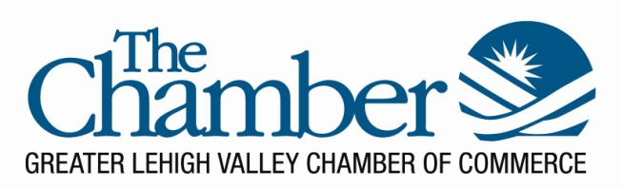
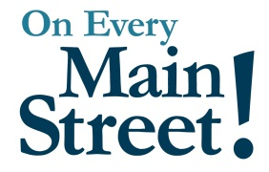

Strategic Priorities for 2020 per the 2019 Board Summit:

- Refine and formalize HR policies
  - Interview, onboarding and exit practices have been reviewed and enriched
  - Partner with Hoffman Hlavac & Easterly, ‎ Labor and Employment practice covers the entire spectrum of employer/employee relations
    - Review and update our employee handbook (Frank and Dawn)
    - Best practices consulting (ongoing – Tony)
  - Alison and Marlyn are our HR leaders and in continuous contact with HHE regarding HR issues in 2020

- Focused programing on family businesses
  - Lehigh University and the Business Council’s Family Business Series
    - Part 1: Building a Family Business That Runs Without YOU
    - Part 2: Best Practices from Best Places to Work Family Business
    - Part 3: Employment Law for Family Businesses
  - The Business Council (formerly SBC) is refocused on family business

- Continue to strengthen our digital tactics and strategies
  - Power of Partnerships podcast – “POPcast” launched in 2020
    - Includes repurposed episodes of our radio show, On Every Main Street, which airs on Monday nights at 6:30 p.m. WDIY 88.1FM
  - Game Changers with Tony Iannelli electronic programming began in April
  - Member Relations team performed a website content audit and reorganization of content. Photos coming in September.
  - A hub-and-spoke, chamber-wide social media plan was developed
  - Platforms optimized for follower engagement through captions, questions and videos
  - Zoom and webinar tools and equipment purchased and in use.
    - Technical Producer position created
  - Moving all data, storage and files to the cloud in August 2020

