SNOW BALL 2023 – Auction Donation Letter

The Lehigh Valley is a special place to live, work and play, a diverse area made up of vibrant communities. This year, The Business Council of the Greater Lehigh Valley Chamber of Commerce is celebrating their 34th Annual Snow Ball signature black tie dinner dance and silent auction on Saturday, February 25th, 2023 at The Club at Twin Lakes (3625 Shankweiler Rd, Allentown, PA 18104).

Snow Ball is more than just a fun evening. It is also an opportunity to give back to your community. Each year, auction proceeds benefit a local nonprofit whose mission is closely aligned with that of the Chamber. In the past 33 years, The Chamber’s Business Council has contributed approximately $680,000 to local organizations thanks to the generosity of attendees and local businesses.

This year, the beneficiary is The Chamber Foundation - Main Street Lehigh Valley. Their mission is to improve the appearance of Every Main Street in the Lehigh Valley through targeted investments in community development projects, facade improvements, streetscape designs, sidewalk beautification and other improvements to our downtowns and surrounding neighborhoods. Over the last 15 years, the Chamber Foundation has given over $1 million directly back to the community.

To continue this tradition of giving, we need your help. Please consider donating an item or making a financial contribution to underwrite an auction item to support the important work of The Main Street Lehigh Valley Foundation. Typically, the retail value of auction items ranges from $100 to $5,000. In addition to the satisfaction of knowing that your contribution is making a difference in the Lehigh Valley, your business will receive valuable exposure prior to and during the gala, which is attended by approximately 250 business and community leaders. All donors are recognized in the Snow Ball program, as well as the silent auction tables and/or during the live auction.

Please help us to continue this great work. We have attached an auction form for you to complete and return with your donation. If you have any questions, please contact Paige Nicholas at 610-737-0565 or paigen@lehighvalleychamber.org. Thank you in advance for your generous support. We look forward to seeing you at Snow Ball!

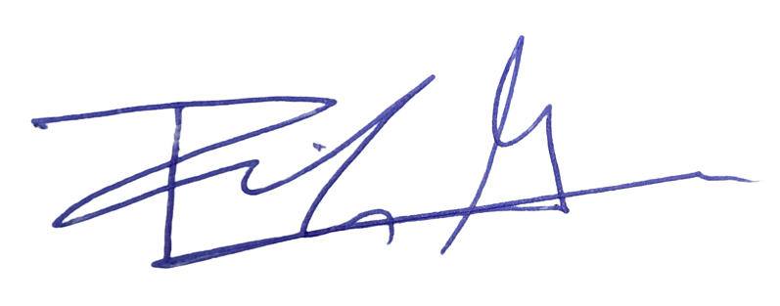
Sincerely,
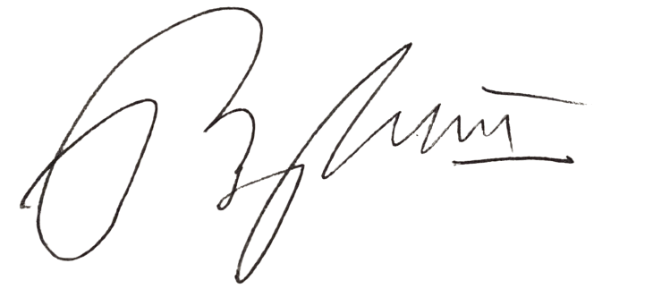

Ben White Ricky Gower
Chair, Small Business Council Chair, Chamber Foundation
Greater Lehigh Valley Chamber of Commerce Main Street Lehigh Valley

2023 Snow Ball Silent Auction – Main Street Lehigh Valley
Donation Form

(For Office Use ONLY)

Description of Item ITEM NUMBER____________

Donated by: (name as it is to appear in auction book)
________________________________________________________________________________________

Donor Address___________________________________________________________________________

City_____________________________State___________Zip____________Phone____________________

E-Mail_____________________________________________________Retail value $__________________

Item/Service description (include expiration dates, restrictions, etc.)
_________________________________________________________________________________________

_________________________________________________________________________________________

_________________________________________________________________________________________

____ Instead of an item, I’d like to donate cash/check: $_____________ (amount enclosed)

OR
____ I prefer to charge this to my (circle one) Visa/MasterCard/Discover/AmEx for $_________________

Card # _______________________________ V-Code ________ Exp. ________ Signature ______________

Donor contact name & phone: Committee member name & phone
_______________________________________ ______________________________________

_______________________________________ ______________________________________

Item received_________ Item delivered to Chamber__________

Deadline: Monday, January 31, 2023

Attach to auction item. Deliver form and item to our Bethlehem Chamber Office:
74 W Broad Street, Suite 240, Bethlehem, PA 18018
You may also fax your completed form to Paige at Fax: 610-330-9177 or e-mail it to paigen@lehighvalleychamber.org

