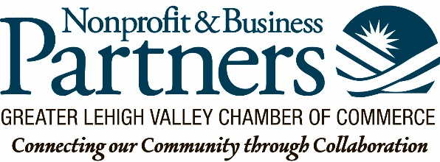

Excellence in Business Award
Applications are now being accepted for the Excellence in Business Award for a Nonprofit Organization. This Excellence in Business Award program is presented by the Small Business Council of the Chamber, and this is just the second year that an Award is being presented exclusively to a NonProfit Organization.
This award is presented to NonProfit organization that has achieved excellence in four areas:

- Collaboration: Actively engages in positive collaborative work with other partners and Generates outcomes and realizes savings that are improved by collaboration with others;
- Governance: Displays an outstanding level of engagement and strategic participation with the board of directors of their organization; with the BOD, provides active oversight of mission, planning and program outcomes; the BOD contributes toward the financial health of the organization.
- Inclusion: Defines how multicultural participation within an organization fosters improved outcomes; embraces diversity in its board, staff, and clients;
- Vision: Develops a collective vision that inspires action; connects that vision to its mission and to community priorities; demonstrates the community benefits of that mission.

Please complete the following and return by 15 April 2019 to lorier@lehighvalleychamber.org

Name: ____________________________________________________________________________

Title/Position: ______________________________________________________________________

NonProfit Organization: ______________________________________________________________

Address: __________________________________________________________________________

Phone: ___________________ Email:_____________________________________________

Number of employees: _____ Full Time _____ Part Time _____ Other (contract, temporary, seasonal)

Please respond to the four questions below (using no more than 500 words for each question).

- Collaboration: How are you engaged in collaborative work with other partners and what has been the outcome of that collaboration?

- Governance: What is the level of engagement of your board of directors and share specifically how the board is committed to the mission and the program outcomes of your organization.

- Inclusion: How does your organization embrace and foster diversity and inclusion?

- Vision: How is your organizations’ vision connected to our mission and your community priorities?

Thank you for your application.
Please complete and return to Lorie at lorier@lehighvalleychamber.org by April 15, 2019. Winners will be acknowledged at the Excellence in Business Awards at ArtsQuest on June 20.

Thanks again for the work you do in our community!

