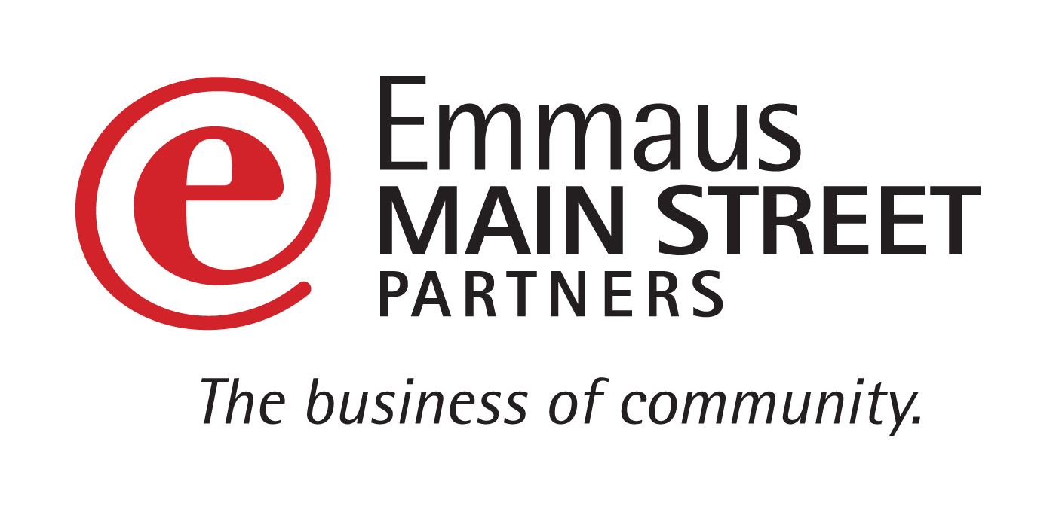
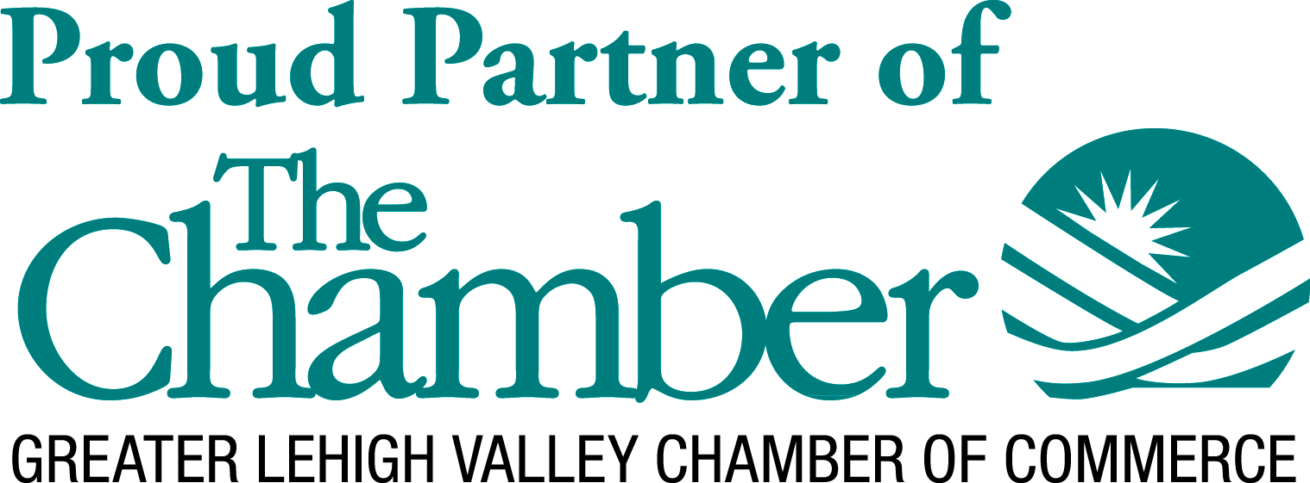


Eat Up East Penn!
Annual East Penn Area Restaurant Week
Sun. February 28th – Sat. March 6th

SPONSORSHIP OPPORTUNITIES
The East Penn Chamber of Commerce and Emmaus Main Street Partners would like to cordially invite you to participate in and support our annual East Penn Area Restaurant Week, taking place from February 28th through March 6th, 2021

2020 was a hard year for everyone but the restaurant industry took an especially hard hit with mandates limiting attendance at businesses. Each year the Chamber of Commerce hosts various Restaurant Weeks throughout the Greater Lehigh Valley. This year, more than ever, we are looking for the support of our business community to rally together to support businesses in our area through East Penn Restaurant Week. This event brings awareness, exposure, foot traffic, and energy to our local restaurants while we advertise on their behalf, driving new and returning business back through their doors OR to purchase takeout and curbside to-go options.

Be a part of this year’s support and success with this opportunity to put your name in front of thousands of people!
Advertising and Promotional Avenues for the event have included / may include the following:
- East Penn Press advertisement (two weeks; end of February and first week of March)
- Gift card giveaway on WAEB AM 790 on Friday Feb 21, Friday Feb 28 and Friday March 6 where host will mention event
- Connecting with iHeart radio to advertise on air and giveaway gift cards where hosts will mention event
- Facebook event pages and posts on EMSP, EPCC, and GLVCC pages
- Ad in Connections magazine – the Chamber’s monthly publication
- Eblasts to the Affiliated Chambers
- Events poster hanging in participating restaurants, sponsors, and high pedestrian areas
- Media mentions online in up to 18 additional PA or Lehigh Valley community event calendars
- Banner hung across Main St in Emmaus by Superior Diner where 11,000 cars pass daily
- Press Release sent to over 200 media contacts across the greater Lehigh Valley
- Money Mailer ad
- Save the Date Cards given out to patrons at participating restaurants in weeks leading up to Restaurant Week with website information
- WFMZ coverage with participating chefs on air

SPONSORSHIP LEVELS (Commit by January 29, 2021 to get the best exposure on marketing materials)
***Checks should be made Payable to “GLVCC”
- PRESENTING SPONSORSHIP $2000 (ONLY ONE! Chamber Member)
  - Your logo and title as a PRESENTING SPONSOR on all Restaurant Week posters / fliers, online and print advertisements
  - Prominent logo placement on East Penn Restaurant Week webpage.
  - Your company logo on all Restaurant locations’ Special Restaurant Week Menus
  - Recognition as the Presenting Sponsor in press release and web listings about Restaurant Week. (web listings may vary depending on site regulations)
  - Recognition as Presenting Sponsor on EPCC, EMSP and GLVCC social media pages. Two individual thank you posts and “tags”/”mentions” throughout course of promoting event.
  - Special recognition in East Penn, Western Lehigh, and Southern Lehigh Chamber e-blast that reaches thousands of Chamber members.
- GOLD SPONSORSHIP $1,200 (Chamber Member) $2,000 (Future Member)
  - Your logo prominent on all Restaurant Week posters / flyers and print advertisements.
  - Prominent logo placement on EastPennRestaurantWeeek.com webpage.
  - Recognition as a Gold Sponsor in press release about Restaurant Week.
  - Recognition as a Gold Sponsor on EPCC, EMSP and GLVCC social media pages. One individual thank you post and “tags”/”mentions” throughout course of promoting event.
  - Recognition in East Penn, Western Lehigh, and Southern Lehigh Chamber e-blast that reaches thousands of Chamber members.
- SILVER SPONSORSHIP $750 (Chamber Member) $1,500 (Future Member)
  - Your logo on all Restaurant Week posters / flyers and print advertisements
  - Your company name listed as a Sliver Sponsor on EastPennRestaurantWeeek.com webpage
  - Recognition as a Silver Sponsor in press release about Restaurant Week.
  - Recognition as a Silver Sponsor on EPCC, EMSP and GLVCC social media pages. (“tags”/”mentions” throughout course of promoting event)
  - Recognition in East Penn, Western Lehigh, and Southern Lehigh Chamber e-blast that reaches thousands of Chamber members.
- BRONZE SPONSORSHIP $500 (Chamber Member) $1,000 (Future Member)
  - Your business name listed as a sponsor on all Restaurant Week posters / flyers and print advertisements
  - Your company name listed as a Bronze Sponsor on EastPennRestaurantWeeek.com webpage
  - Recognition as a Bronze Sponsor in press release about Restaurant Week.
  - Recognition as a Bronze Sponsor on EPCC, EMSP and GLVCC social media pages. (“tags”/”mentions” throughout course of promoting event)
- SUPPORTING SPONSORSHIP $250 (Chamber Member) $500 (Future Member)
  - Your business name listed as a sponsor on all Restaurant Week posters / flyers and print advertisements
  - Recognition as a Supporting Sponsor in press release about Restaurant Week.
  - Recognition as a Supporting Sponsor on EPCC, EMSP and GLVCC social media pages. (“tags”/”mentions” throughout course of promoting event)

