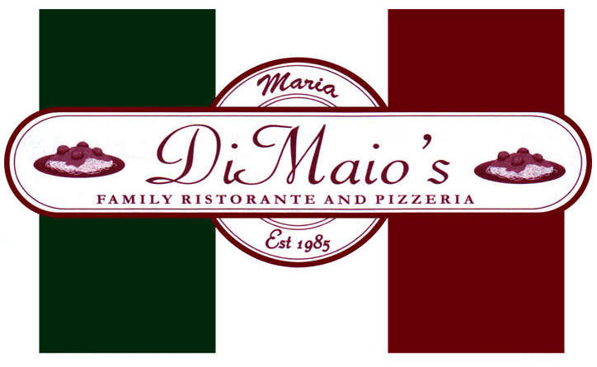
7TH ANNUAL
RESTAURANT WEEK MENU
JULY 30 THRU AUG 4TH

DINNER
4-8:30 PM
$20.00
plus tax per person
- no substitutions
- no plate sharing

APPETIZER
*choice of one*

FRIED CALAMARI
INSALATA CAPRESE
MOZZARELLA STICKS

*choice of one*
all served with our homemade bread

HOUSE SALAD
SOUP

ENTRÉE
*choice of one*

CHICKEN MARSALA OVER pasta
WHITE CLAM SAUCE over pasta
SHRIMP SCAMPI OVER pasta
EGGPLANT PARMIGIANA with side of pasta

DESSERT

MINI CANNOLI
REGULAR OR DECAF COFFEE

