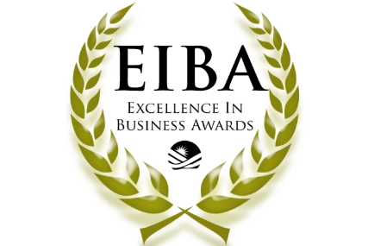

The 2023 Excellence in Business Awards
Wednesday, June 14, 2023 | 5:00-7:00 p.m.
Northampton Country Club - 5049 William Penn Highway, Easton, PA 18042

Rules & Eligibility Requirements

We are thrilled that you have chosen to apply for the 2023 Excellence in Business Awards (EIBA) sponsored by the Small Business Council of the Greater Lehigh Valley Chamber of Commerce.

The Excellence in Business Awards are presented to companies and individuals who exemplify outstanding business practice, supported by their mission statement, Chamber and community involvement, and customer satisfaction, as well as their demonstrated commitment to quality, leadership, marketing, training, and development.

The six EIBA categories are:
- Excellent Micro Business– presented to a business with 1-9 employees
- Excellent Small Business – presented to a business with 10-49 employees
- Excellent Large Business – presented to a business with 50+ employees
- Excellent Emerging Business – presented to a business less than 3 years old
- Excellent Non-Profit – presented to a non-profit organization
- Lifetime Achievement Award – presented to an individual in business

The rules and eligibility requirements are as follows. To qualify, a candidate must meet the following criteria:
- Be an active Chamber member for at least one year.
- Represent a sole proprietorship, partnership, limited liability company or locally owned, closely held corporation.
- Must not be a previous winner in the last five years.
- Must select a representative to deliver a brief acceptance speech at the 2023 Excellence in Business Awards cocktail reception.

Application Instructions:
- Applicants may self-nominate or nominate another business/individual.
- Deadline for receiving completed applications is noon on Friday, March 31, 2023. All company representatives who submit applications will be personally notified of the results following the judging meeting in April.
- Applications should be submitted via email to Paige Nicholas at the Chamber - PaigeN@lehighvalleychamber.org. Applications will also be posted on the Chamber web site: https://www.lehighvalleychamber.org/eibapplication.html

Media Opportunities:
Winners will receive the artwork to include in their literature and advertising, promoting this recognition and honor. The companies may publicize the honor and use the title on promotional literature, advertising, and identity packages (letterhead, etc.). The winning companies will be recognized by Chamber media outlets and in public relations materials.

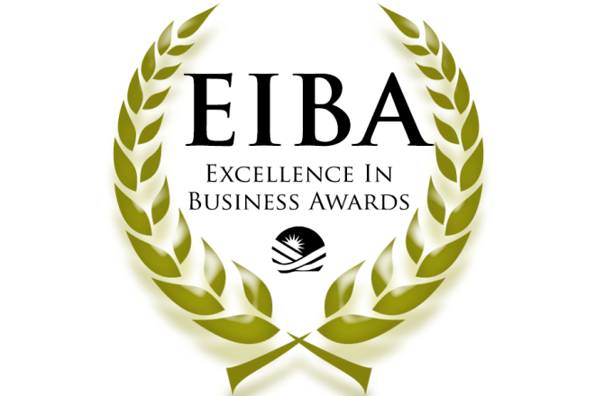

Application Form

Name: __________________________________________________________________________________

Title/Position: ____________________________________________________________________________

Company: _______________________________________________________________________________

Address: ________________________________________________________________________________

Phone: ________________________ Fax: ____________________________

Email: __________________________________________________________________________________

Year Business started: ________________

Number of employees: _____ Full Time _____ Part Time _____ Other (contract, temporary, seasonal)

Categories:
❑ Excellent Micro Business (1-9 employees)
❑ Excellent Small Business (10-49 employees)
❑ Excellent Large Business (50+ employees)
❑ Excellent Emerging Business (less than 3 years old)
❑ Excellent Non-Profit
❑ Lifetime Achievement Award

Please answer each question on your application.

- Describe your commitment to the community. How involved are you/your employees in the Chamber and the community? Describe the length and type of community service, positions or offices held, and how this involvement benefits both the community organization and your company. (20 points)

- Describe your external commitment to excellence. Please share how you/your company demonstrate(s) excellence in customer satisfaction and a commitment to quality. How do you compare to others in the same industry or field of expertise? How do you measure quality and how do you know your quality control efforts are effective? List any Certificates of Recognition, Company Awards, etc. (20 points)

- Describe your internal commitment to excellence. Please share how you/your company demonstrate(s) excellence with your employees, your own professional development, and your products or services. Provide examples of what you have done in the last 12 months to implement your philosophy as it relates to training and development. (20 points)

- Why do you believe you are qualified to receive this award? How does your company demonstrate continuous, meaningful leadership in your business and how does that result in a level of excellence? (20 points)

- Please attach a total of two testimonial letters (10 points each; 20 total)

Please return completed application no later than noon on Friday, March 31, 2023 to:
Paige Nicholas
Greater Lehigh Valley Chamber of Commerce, Bethlehem Chamber Office
74 W Broad Street, Suite 240, Bethlehem, PA 18018
E-mail: PaigeN@lehighvalleychamber.org
Mobile: 610-737-0565 Fax: 610-330-9177

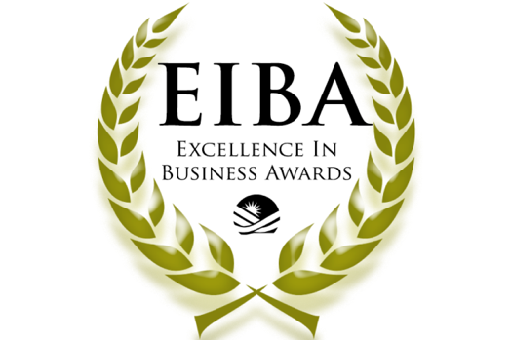
Past Recipients

3rd & Ferry Fish Market

ABE Doors & Windows

A D Computer Corporation

AFC First Financial Corporation

Air Products

Allied Building Corporation/a Scarcia Company

Allentown School District - Thomas Parker
American Bank

American Hairlines

AmericaVen

Andy Daub

Anthony Ashley – Nina Tulio

Apollo Grill

Ashley Development Corporation

ASR Media Productions - Ashley Russo

Bayou Boys, Mo Taylor

Bear Creek Mountain Resort - George Pitsilos

Beauty Alibi - Carmen Toro

Benchmark Civil Engineering Services, Inc.

Bennett Automotive Group

Berkshire Hathaway

Best Western Lehigh Valley Conference Center

Boyle Associates

Boyle Construction, Inc.

Boys & Girls Club of Easton - Gabriel Dean Young

Bradbury-Sullivan LGBT Community Center

Bradbury-Sullivan LGBT Community Center - Adrian Shanker

Brown-Daub

Cancer Support Community - Amanda Buss

CC Inc. Construction Services

Chad Tyrrell

Concannon Miller & Co.

Corporate Environments

Creative Closets®, Ltd.

Crest Financial Group - Eric Boyle

CSI

Dale Carnegie Training

Dan’s Camera City

Deiter Bros. Fuel Company

Denise Maiatico

DesignPoint, Inc

Don Juan Mex Grill

EBC Printing - Murtaza Jaffer

enTrust Merchant Services
Eastern PA Health Network

Equinox Benefits Consulting - Tom Groves
FIA NYC

FireRock Productions

First Commonwealth Federal Credit Union - Donna LoStocco
Fitzpatrick Lentz and Bubba - Marie McConnell

Gross McGinley - Constance Nelson

Habitat for Humanity of the Lehigh Valley - Jessica Elliott
Haggerty Services, LLC

HMK Insurance

HindlePower

Jack’s Glass, Inc.

Joanne Kostecky Garden Designs, Inc.

John Yurconic Agency

Keystone Consulting Engineers

Lehigh County

Liquid

LV Planning Commission - Becky Bradley

LVHN - Erin Ludwig

Miers Insurance

Mike Lichtenberger

Miller Symphony Hall - Lucy Bloise

Mishka Vodka

MKSD architects

Moravian Book Shop

Morris Black and Sons, Inc.

Northampton County

NOVUS ACS

Oaks Printing Company

Ondra-Huyett Associates, Inc.

OraSure Technologies Inc. (STC Technologies)

Originate Ventures

Patt, White/GMAC Real Estate

Plantique, Inc.

Playtime Daycare - Paula Espinal

PostNet - Marisa Lenci
PPL Electric Utilities

Rich Mar Florist

RLB

Servpro of Easton Bethlehem and Whitehall

Scott Chevrolet, Inc.

Spillman Farmer Architects

Spillman Farmer Architects - Christa Duelberg-Kraftician

STC Technologies

Sunburst Property Management

Susan's Gourmet Shop & Catering

Susan Bella Jewelry

Sweet Girlz Bakery

Tina Hamilton

Tru-Comfort, Inc.

Valley Youth House

Victaulic

Vistacom Communications, Inc.

Walp's Restaurant & Guest House

West Side Hammer Electric (R.I. Hammer, Inc)

William Elek, Ltd.

Yeager's Fuel, Inc.

Zator Law Offices

